Oleynik Vladislav

Task #2

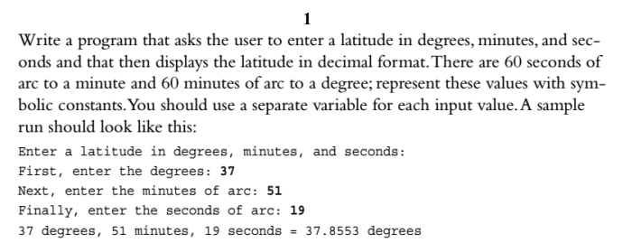

Code:

#include <iostream>

using namespace std;

void introductionMessage()

{

cout << "Enter a latitude in degrees, minutes, and seconds\n";

}

int enterAndReturnDegrees()

{

cout << "First, enter the degrees: ";

int value;

cin >> value;

return value;

}

int enterAndReturnMinutes()

{

cout << "Next, enter the minutes of arc: ";

int value;

cin >> value;

return value;

}

int enterAndReturnSeconds()

{

cout << "Finally, enter the seconds of arc: ";

int value;

cin >> value;

return value;

}

double transferToDegrees(int degrees, int minutes, int seconds)

{

return degrees + (minutes / 60) + (seconds / 3600);

}

void summarise(double sum_degrees, int degrees, int minutes, int seconds)

{

cout << degrees << " degrees, " << minutes << " minutes, " << seconds << " seconds = " << sum_degrees << " degrees\n";

}

int main()

{

introductionMessage();

int degrees = enterAndReturnDegrees();

int minutes = enterAndReturnMinutes();

int seconds = enterAndReturnSeconds();

double sum_degrees = transferToDegrees(degrees, minutes, seconds);

summarise(sum_degrees, degrees, minutes, seconds);

return 0;

}

Output:

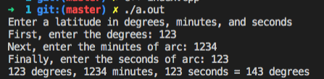

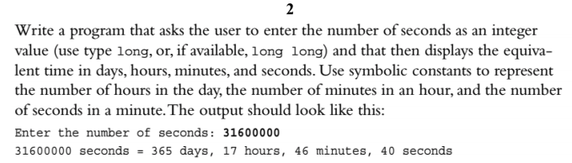

Code:

#include <iostream>

using namespace std;

long long enterAndReturnSeconds()

{

cout << "Enter the number of seconds: ";

int value;

cin >> value;

return value;

}

void transferAndOutputSecondsToAnotherDimenstions(long long seconds)

{

long long initialSeconds = seconds;

long long day = seconds / (24 * 3600);

seconds = seconds % (24 * 3600);

long long hour = seconds / 3600;

seconds %= 3600;

long long minutes = seconds / 60;

seconds %= 60;

long long _seconds = seconds;

cout << initialSeconds << " seconds = " << day << " "

<< "days, " << hour

<< " hours, " << minutes << " minutes, " << _seconds << " seconds " << endl;

}

int main()

{

long long seconds = enterAndReturnSeconds();

transferAndOutputSecondsToAnotherDimenstions(seconds);

return 0;

}



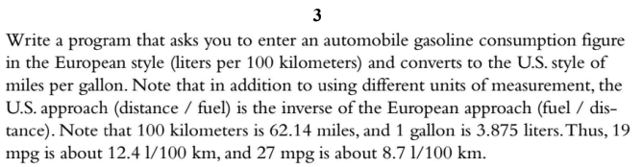

#include <iostream>

using namespace std;

int enterAndReturn()

{

cout << "Enter the value: ";

int value;

cin >> value;

return value;

}

// 235.215/(1 L/100km) = 235.215 US mpg

int convert(int val)

{

return val * 235.215;

}

int main()

{

int val = enterAndReturn();

cout << convert(val) << endl;

return 0;

}



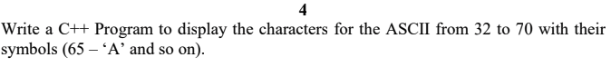

#include <iostream>

using namespace std;

int main()

{

for (int i = 32; i <= 70; i++)

cout << (char)i << " ";

return 0;

}

